Unveiling the Complexity of Food Webs: A Comprehensive Overview of Definitions, Scales, and Mechanisms
Tanya Strydom
Jennifer A. Dunne
Timothée Poisot
Andrew P. Beckerman
2024-09-16
Abstract
Food webs are a useful abstraction and representation of the feeding links between species in a community and are used to infer many ecosystem level processes. However, the different theories, mechanisms, and criteria that underpin how a food web is defined and, ultimately, constructed means that not all food webs are representing the same ecological process. Here we present a synthesis of the different assumptions, scales and mechanisms that are used to define different ecological networks ranging from metawebs (an inventory of all potential interactions) to fully realised networks (interactions that occur within a given community over a certain timescale). Illuminating the assumptions, scales, and mechanisms of network inference allows a formal categorisation of how to use networks to answer key ecological and conservation questions and defines guidelines to prevent unintentional misuse or misinterpretation.
At the heart of modern biodiversity science are a set of concepts and theories about biodiversity, stability and function. These relate to the abundance, distribution and services that biodiversity provides, and how biodiversity – as an interconnected set of species – responds to multiple stressors. The interaction between species (or individuals) is one of the fundamental building blocks of ecological communities provide a powerful abstraction that can help quantify, conceptualise, and understand biodiversity dynamics, and ultimately, one hopes, make prediction, mitigate change and manage services [ref]. Such network representations of biodiversity (including within species diversity) are increasingly argued to be an asset to predictive ecology, climate change mitigation and resource management. Here, it is argued that characterising biodiversity in a network will allow deeper capacity to understand and predict the abundance, distribution, dynamics and services provided by multiple species facing multiple stressors.
However, the way that a network is constructed (encoded) defines an epistemology of the network concept which, we argue, can influence the resulting observations and conclusions about pattern and mechanisms that are made [1,2]. This process of constructing networks has two major pillars: the data and theory, the latter representing an expression of mechanism and process giving rise to patterns that emerge from collating interactions among species. Each of these pillars carries with it a set of practical, semantic and conceptual constraints that not only influence progress in making network ecology more valuable and potentially predictive, but help define the spatial, temporal and evolutionary scale of assumptions we make and predictions we might generate from the networks.
With respect to data, it is extremely challenging to actually record species interactions in the field [3,4]. Despite notable herculean efforts (Woodward? Benguela? [5]), actual coverage of ‘real world’ interaction data remains sparse [6]. Against this practical challenge, there is additionally high variance in the terminology we use to define networks. Finally, the mathematical and statistical tools we use to construct, conceptualise, analyse and predict with these networks are also highly variable.
- what are the underlying assumptions about nodes, edges, scale and process that are made when we attempt to delimit and describe a food webs;
- are there families of commonly used tools that map onto assumptions about scales and processes;
The provision of this detail ultimately leads to a set of insights and conclusions about whether, when and under what conditions network representations of biodiversity can contribute to the advancement of ecological theory and generate value in predictive ecology. Specifically, we finish this perspective with an overview of fundamental questions in ecology that we think can benefit from network thinking and a proposal that such thinking can accelerate our capacity to predict the impact of multiple stressors on biodiverse communities.

1. Setting the Scene: The Not So Basics of Nodes and Edges
Defining a food web seems simple; it is the representation of the interactions (edges) between species (nodes), however the definition of ‘edges’ and ‘nodes’, as well as the scale at which they are aggregated can take many forms [7]. Networks can be constructed at the population (the links among individuals), community (the links between species), or metacommunity (changes between locations) level. Even if one were to limit their scope to thinking of interaction networks only in terms of food webs at the community-level there are still many ways to define the various components of the network Panel A of 1, one needs to understand the different intentions/assumptions that are made when a food web is constructed. Although the main goal of constructing a food web is to capture and represent the feeding links between species there are many ways to define the nodes (e.g., species or taxonomic group), edges (e.g., potential or realised feeding links), the magnitude of the edges (e.g., binary vs probabilistic), and even how the network itself is delimited (does it represent an aggregation of interactions over time?).
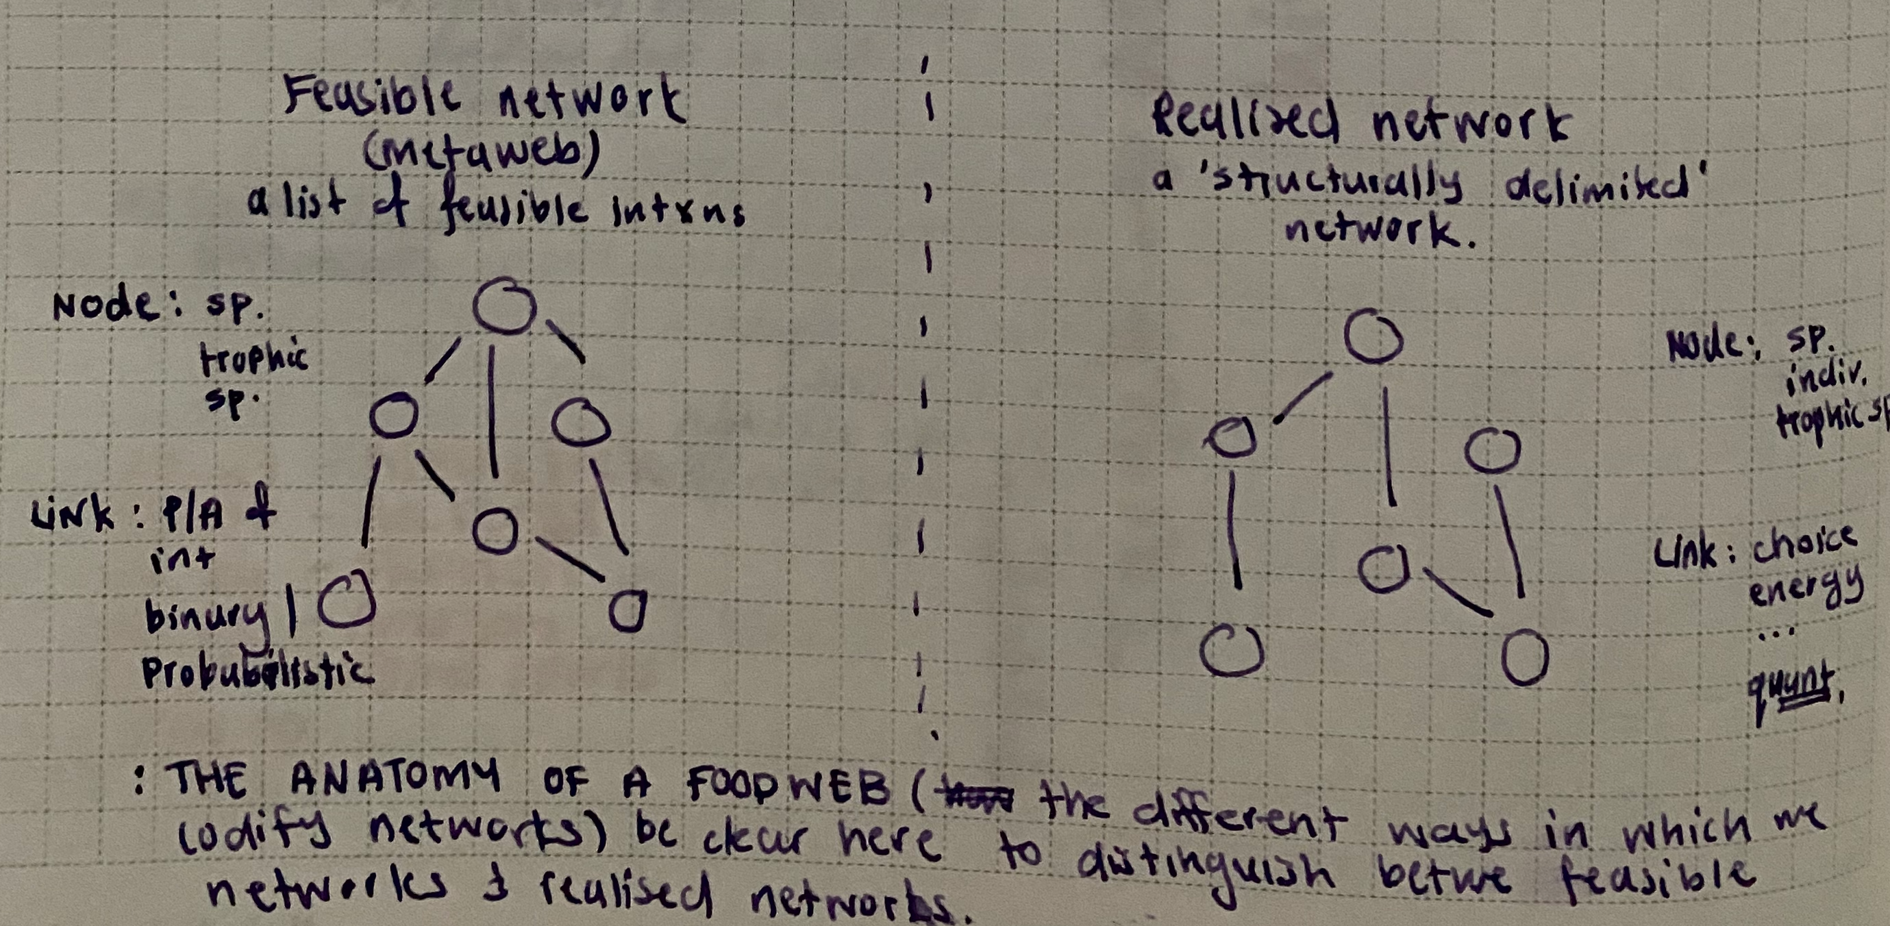
Figure 1: The many ways in which a food web can be defined and described at the node, edge, and even network level.

1.0.1 How do we define a node?
Although this may seem an elementary question in the context of food webs — a node should represent a (taxonomic) species, the reality is that nodes can often represent an aggregation of different species - so called ‘trophic species’ or segregation of species by life stages. Representing nodes as non-taxonomic species can be useful in certain contexts [8,9] and in cases where the adult and larval stages of a species have different diets it may make ecological sense [10] meaning that it is not uncommon that networks often have nodes that have different definitions of a ‘species’ e.g. consisting of both taxonomic and trophic species. Practical implications of how we are aggregating the nodes is that the resolution may not always be ‘pixel perfect’ i.e., we may be unable to assess the co-extinction risk of a species pair, however there is value in having nodes that represent an aggregation of species, as these convey a much more general overview of how the links are distributed within the community.

1.0.2 What is meant by an edge?
At its core, links within food webs can be thought of as a representation of either feeding links between species - be that realised [11] or potential [12], or representative of fluxes within the community/system e.g., energy transfer or material flow [13]. How we specify links will influence the resulting structure of the network - and the inferences we will make thereof. For example taking a food web that consists of links representing all potential feeding links for a community (i.e., a metaweb) will be meaningless if one is interested in understanding the flow of energy through the network as the links within a metaweb do not represent environmental/energetic constraints. In addition to the various ways of defining the links between species pairs there are also a myriad of ways in which the links themselves can be quantified. Links between species are often treated as being present or absent (i.e., binary) but it is also possible to use probabilities [which quantifies how likely an interaction is to occur, 14,15] or continuous measurements [which quantifies the strength of of an interaction, 16].

1.0.3 Putting the parts together
The ingredients one uses to construct networks generates a unique representation of the mechanisms (see Section 2) that allow inference and reasoning about the structure, aspects of dynamics (e.g., stability), and potentially the function of communities (e.g., flux). It is thus important to keep in mind that different networks are going to be representing different processes and that can only be used for inference of some but not all aspects of the community at large. Here it may be meaningful to contextualise the different ‘types’ of food webs within the larger research programmes (or even practical needs) that have been driving the construction of them.
Before thinking about the ways in which we can predict networks it is perhaps meaningful to take a step back and think about the different criteria that must be met in order for an interaction to be able to occur between two species, specifically thinking of this in terms of distinguishing between the feasibility versus realisation of an interaction and how these are determined (and defined by) different ‘rules’/mechanisms. If we look at this feasibility-reality continuum (Figure 2) it is clear how the different predictive approaches (methods) tend to fall within one of the broader categories identified (distinguished) in the triangle. This is not to say that this shortcoming should be viewed as a ‘bug’ but rather a ‘feature’ of the field as it allows one to engage with, as well as construct networks at different scales, which is particularly valuable if one takes into consideration the considerable ‘data cost’ of predicting well resolved, realised networks in comparison to constructing high-level metawebs. However, it is important that there is an awareness and acknowledgement of where within this feasibility-reality one is working at and how this will impact and limit the contexts in which the resulting network can be used and applied within.

2. From Nodes and Edges to Scales, Context, and Processes
Armed with these basics, it is now possible to review the scales and assumptions that are made by a wide range of tools to assist in constructing networks against poor data with the hope of capturing important processes that underpin accurate prediction. Our thesis centres on a four-tier conceptualization of networks: evolutionary compatibility, co-occurrence, feasibility, abundance, predator choice, and non-trophic interactions. In the following sections we review each of these and then provide a synthesis among them.

2.1 Understanding the processes that determine species interactions
Processes that are all-or-nothing (possibility) vs processes that are context dependent (likelihood). Processes form the underlying logic of models (and arguably, no, for sure even empirical data) capture. This means also the interplay of the two, i.e., the use of models to ‘gap fill’ within existing empirical dataset [17,18]. Ultimately when we put this all together it will influence how we can (and should) use the resulting network. Here we present Figure 2 some of the processes that have been shown to influence either/or the feasibility (possibility) of an interaction occurring between two species or if a feasible interaction is realised (likelihood of realisation) within the specific environmental/community context. Of course these processes do not function in a vacuum and do interact with/influence one another but it is still beneficial to present them as such as these are often the underlying processes that influence model development, the criteria for data collection in the field, and the scale of organisation for which they are relevant (species, population, community).
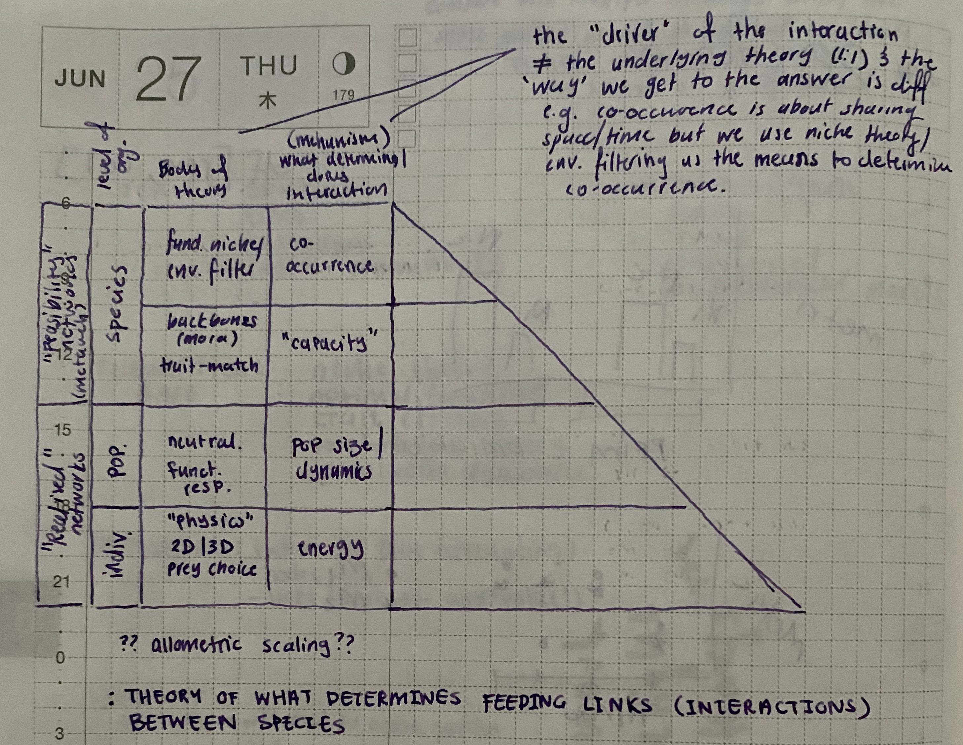
Figure 2: TODO.
Evolutionary compatibility
There is compelling evidence that the possibility of an interaction occurring between two species is the result of their shared (co)evolutionary history [19–21]. In the more proximal sense this is manifested as the ‘trait complementarity’ between two species, whereby one species (the predator) has the ‘correct’ set of traits that allow it to chase, capture, kill, and consume the other species (the prey). For species pairs where this condition is not met the link is deemed to be forbidden [4]; i.e., not physically possible and will always be absent within the network. In the context of trying to determine the feasibility (i.e., the possibility) of an interaction, phylogeny is an excellent predictor [22,23] and allows one to construct what can be considered to be a metaweb. In terms of thinking about the anatomy of an ‘feasibility network’ one should be aware that it is possible to represent interactions as either binary (feasible/forbidden; i.e., the traditional definition of a metaweb [12]) or as a probability [15], where the probability represents how likely that the interaction between to species is feasible (what is the possibility of this interaction occurring?).
(Co)occurrence
Although the outright assumption that because two species are co-occurring it must mean that they are interacting is inherently flawed [24], it is of course impossible for two species to interact (at least in terms of feeding links) if they are not co-occurring in time and space. Thus co-occurrence data alone is insufficient to build an accurate and ecologically meaningful representation of a food web having information on the co-occurrence of species can further aid us in refining metawebs by allowing us to downsample the network based on the species found in a specific location, or even add additional uncertainty based in how likely species are to co-occur [25]. Additionally the interplay between the interaction between a species pair and their co-occurrence is meaningful when one is operating in the space of trying to determine the distribution of a species [26], and forms a key component of some of the next generation species distribution models e.g., joint SDMs [27].
Abundance
The abundance of the different species within the community can influence the likelihood of an interaction occurring in a myriad of ways. There is the argument that networks (and the interactions that make them up) are driven by only the abundance of the different species and not the characteristics (traits), sensu neutral processes and have been formalised with the neutral model [28], as well as statistical tools [29]. Alternatively the abundance of species in a community can influence which interactions are ultimately realised [15,30].
Predator choice (energetic cost)
Ultimately, predator choice is underpinned by the energetic cost-benefit of trying to catch, kill, and consume prey, and is well described within optimal foraging theory [ref] and rests on the idea that the prey a predator chooses to target is one that will have the greatest return on energy with the lowest energetic cost. There are additional bodies of work that attempt to include the cost of movement that the environment imposes on an individual [31] as well as 2D/3D search space [32]. In terms of formalising these processes in the context of predicting networks using diet models [33,34] that have predator choice determined by the handling time, energy content, prey density, and predator attack rate. [35] developed a model that moves the energy of the system into different modules related to the process of the predator acquiring energy from the prey i.e., compartmentation in food webs [36].
Indirect interactions
The realisation (presence/absence) or strength of trophic interactions themselves can also be modified by other, indirect (non-trophic), interactions [37,38], this can be either ‘directly’ through e.g., competition or ‘indirectly’ e.g., mutualistic/facilitative interactions will alter the fine-scale distribution and abundance of some species [39,40].
It should be self evident that the different processes discussed above are all ultimately going to influence the realisation of interactions as well as the structure of a network, however they are acting at different scales of organisation. Both the co-occurrence and the evolutionary compatibility are valid at the scale of the species pair of interest, that is the possibility of an interaction being present/absent is assessed at the pairwise level and one is left with a ‘list’ of interactions that are present/absent. Although it is possible to build a network (i.e., metaweb) from this information it is important to be aware that the structure of this network is not constrained by real-world dynamics or conditions (i.e., community context), just because species are able to interact does not mean that they will [30]. In order to construct a network who’s structure is a closer approximation of reality (localised interactions) one needs to take into consideration properties of the community as a whole and not just the two species of interest.
downsampling paragraph??

3. Network prediction is nuanced
The different models that are used to either predict or construct networks have an underlying philosophy that often only captures one or a few of the processes discussed in Section 2.1, has implications for how the resulting network is defined Section 1, which will ultimately delimit and define what inferences can be made from the resulting network. Selecting a model for the task of network prediction should come down to two things; what aspect of a food web one is interested in predicting, and what data are available, necessary, and sufficient, and what is the purpose of wanting to predict a network? It is important that a researcher is aware of this to ensure that the appropriate model is selected. Broadly researchers will be interested in predicting/constructing two different types of networks; metawebs, which is essentially a list of all interactions that are possible for a specific community (i.e., at the scale of the species pairs), or being able to predict location specific, realised, networks for the community (i.e., at the scale of the community). The nature of metawebs means that they are unable to capture the structural metrics of realised/‘real-world’ networks [41]. The researcher is also constrained by the data needs of both the model as well as the network type; for example in order to predict a realised network one needs additional community/population level data (e.g., abundance), making metawebs a more feasible choice in data-poor contexts (e.g., [42] construct a metaweb using a species list and a phylogenetic tree). The final question is assessing the purpose of predicting a network - is it to create a series of simulated, species agnostic but still ecologically plausible, networks [e.g.,] or to predict a network for a specific community at a specific location. It is these three points that will ultimately dictate which model is going to best allow one to predict the appropriate network.

3.1 Models that predict structure
Although we identify mechanisms that determine species interactions in Section 2.1 not all models that are used to predict networks operate at this ‘mechanistic’ level (at least in absolute terms), but rather represent the structure of a network based on a series of a priori assumptions of network connectance (e.g., the niche model [9]; although see [43] for a parameter-free model) or other structural features of a realised network (e.g., stochastic block model, [44]). Importantly these structural models do not make species specific predictions (they are usually species agnostic and treat nodes as trophic species) and so cannot be used to determine if an interaction is either possible or realised between two species (i.e.,one cannot use these models to determine if species $a$ eats species $b$). Although this means this suite of models are unsuitable as tools for predicting interactions, they have been shown to be sufficient tools to predict the structure of networks [45].

3.2 How do we predict food webs?
There as many ways to predict networks as what there is to define them and along with taking into consideration the points raised in the previous section it is also beneficial to think about the context in which the different models were developed - and how this will influence the networks that they produce… Also it is not feasibly possible to list every single approach that has been developed to predict networks and so we will present what we believe to be the broad families that represent the different approaches to predicting networks Table 1, particularly how these relate to the processes identified in Section 2.1, as well as models that predict network structure (see Section 3.1).A more extensive overview of the different models that fall with in the different model families can be found in SuppMat 1 and for a more detailed breakdown of the different ‘traits’ of the model families refer to SuppMat 2.
Table 1: A summary of the different families of tools that can be used to generate food webs.
Model family | Assumptions | Data/process | ‘Limitation’ | Network type | Key reference
null | Links are randomly distributed within a network |  | parameter assumptions, species agnostic | structural network
neutral | Network structure is random, but species abundance determines links between nodes | abundance | parameter assumptions | structural network | [28]
resource | Networks are interval, species can be ordered on a ‘niche axis’ |  | parameter assumptions, species agnostic | structural network | [45]
generative | Networks are determined by their structural features |  | need real world networks | structural network
energetic | Interactions are determined by energetic costs | abundance + energy | does not account for forbidden links in terms of evolutionary compatibility | ‘energy’ network
graph embedding | Interactions can be predicted from the latent traits of networks | evolutionary compatibility | need real world networks | metaweb | [42]
trait matching | Interactions can be inferred by a mechanistic framework/relationships | evolutionary compatibility | well studied species/communities | metaweb | [46]
binary classifiers | Interactions can be predicted by learning the relationship between interactions and ecologically relevant predictors | evolutionary compatibility | need real world networks | metaweb | [47]
expert knowledge | ‘Boots on the ground’ ecological knowledge and observations | evolutionary compatibility | well studied species/communities | metaweb
data scavenging | Webscraping to create networks from online databases |  | need real world networks | metaweb | [48] (if you squint?)
co-occurrence | co-occurrence patterns arise from interactions so we can use these patterns to reverse engineer the interactions | co-occurrence | does not account for forbidden links in terms of evolutionary compatibility or account for energy constraints | co-occurrence network

There is a bit of a ‘point of conflict’ between those calling for ‘pixel perfect’, regional scale data [11,49] and for the means to generate networks that are ecologically plausible representations (sensu structural networks). This represents two challenges; one is that models that represent generalisations of networks often lack the ability to retrieve any species/community specificity which limits their utility for real world, species-driven scenarios e.g., species driven conservation efforts [50], however networks that are constructed through either (most) empirical observations or through predictive means are fundamentally going to represent metawebs, i.e., lack constrained links, a representation of structure, or energy flow…

4. Making Progress with Networks

4.1 Further development of models and tools
As we show in Table 1 there has been a suite of models that have been developed to predict trophic links, however we are lacking in tools that are explicitly taking into consideration estimating both the feasibility as well as realisation of links, i.e., both interactions and structure simultaneously [51]. This could be addressed either through the development of tools that do both (predict both interactions and structure), or it might be possible to do a ensemble modelling approach [52]. Alternatively the development of tools that will allow for the downsampling of metawebs into realised networks [e.g., 53], although deciding exactly what is driving differences between local networks and the regional metaweb might not be that simple [54].

4.2 At what scale should we be predicting networks?
Look at [55]
We lack a clear agenda (and conceptualisation) as to what the appropriate level of aggregation is for a ‘network’. Realistically most empirical networks are more aligned with metawebs as opposed to realised networks as they are often the result of some sort of aggregation of observations across time, this creates a two-fold problem. Firstly, we need to think about how this affects any sort of development of theory that sits closer to the ‘realised network’ side of the spectrum - how often are we trying to ask and answer questions about realised networks using feasible networks? The second is that this lack of ‘direction’ as to how we should define a network is (actually) probably one of the biggest barriers that is affecting the use of networks in applied settings… By define I mean both delimiting the time and geographic scale at which a network is aggregated at [56]. This is important because it can influence the inferences made, e.g., the large body of work (landscape theory for food web architecture) that showcases how different species use the landscape will influence network dynamics [57].

4.3 How should we use different networks?
What for and how we can use networks is perhaps one of the biggest ‘gaps’ we have in network ecology (Tim’s EBV ms), and there is a serious need to start drawing clear, ecological links between network form and function [although see 58]. That being said one of the most important things we can do is to be aware of the parameter space that is possible given a specific definition of a network and operate within those parameters. And we should use this in how we also evaluate/benchmark the performance of the different models as well; [59] presents a set of guidelines for assessing how well a model recovers pairwise interactions but we lack any clear strategies for benchmarking structure.

5. Concluding remarks
I think a big take home will (hopefully) be how different approaches do better in different situations and so you as an end user need to take this into consideration and pick accordingly. I think [60] might have (and share) some thoughts on this. I feel like I need to look at [61] but maybe not exactly in this context but vaguely adjacent. This is sort of the crux of the argument presented in [62] as well.
Do we expect there to be differences when thinking about unipartite vs bipartite networks? Is there underlying ecology/theory that would assume that different mechanisms (and thus models) are relevant in these two ‘systems’.
- The [63] paper looks at some methods but is specifically looking at a bipartite world…
Another time perspective question is when do we determine a link to be ‘real’… In the context of feasible networks this is perhaps clearer - all things equal would the predator be bale to consume the prey. However in the realised space there is also the question of the long term ‘energetic feasibility’ of an interaction - just because an interaction is possible in the now is it able to sustain a population in the long term. And what is the scale for that long term - are we thinking at the generational scale? Because ultimately when we are constructing a network we are aggregating not only across space but also across time.

References
1. Proulx, S.R. et al. (2005) Network thinking in ecology and evolution. Trends in Ecology & Evolution 20, 345–353
2. Brimacombe, C. et al. (2023) Shortcomings of reusing species interaction networks created by different sets of researchers. PLOS Biology 21, e3002068
3. Jordano, P. (2016) Chasing Ecological Interactions. PLOS Biology 14, e1002559
4. Jordano, P. (2016) Sampling networks of ecological interactions. Functional Ecology DOI: 10.1111/1365-2435.12763
5. Maiorano, L. et al. (2020) TETRA-EU 1.0: A species-level trophic metaweb of European tetrapods. Global Ecology and Biogeography 29, 1452–1457
6. Poisot, T. et al. (2021) Global knowledge gaps in species interaction networks data. Journal of Biogeography 48, 1552–1563
7. Poisot, T. et al. (2016) Describe, understand and predict: Why do we need networks in ecology? Functional Ecology 30, 1878–1882
8. Yodzis, P. (1982) The Compartmentation of Real and Assembled Ecosystems. The American Naturalist 120, 551–570
9. Williams, R.J. and Martinez, N.D. (2000) Simple rules yield complex food webs. Nature 404, 180–183
10. Clegg, T. et al. (2018) The impact of intraspecific variation on food web structure. Ecology 99, 2712–2720
11. Pringle, R.M. (2020) Untangling Food Webs. In Unsolved Problems in Ecology, pp. 225–238, Princeton University Press
12. Dunne, J.A. (2006) The Network Structure of Food Webs. In Ecological networks: Linking structure and dynamics (Dunne, J. A. and Pascual, M., eds), pp. 27–86, Oxford University Press
13. Lindeman, R.L. (1942) The Trophic-Dynamic Aspect of Ecology. Ecology 23, 399–417
14. Poisot, T. et al. (2016) The structure of probabilistic networks. Methods in Ecology and Evolution 7, 303–312
15. Banville, F. et al. (2024) Deciphering probabilistic species interaction networksEcoEvoRxiv
16. Berlow, E.L. et al. (2004) Interaction strengths in food webs: Issues and opportunities. Journal of Animal Ecology 73, 585–598
17. Biton, B. et al. (2024) Inductive link prediction boosts data availability and enables cross-community link prediction in ecological networks
18. Stock, M. (2021) Pairwise learning for predicting pollination interactions based on traits and phylogeny. Ecological Modelling
19. Segar, S.T. et al. (2020) The Role of Evolution in Shaping Ecological Networks. Trends in Ecology & Evolution 35, 454–466
20. Gómez, J.M. et al. (2010) Ecological interactions are evolutionarily conserved across the entire tree of life. Nature 465, 918–921
21. Dalla Riva, G.V. and Stouffer, D.B. (2016) Exploring the evolutionary signature of food webs’ backbones using functional traits. Oikos 125, 446–456
22. Strydom, T. et al. (2022) Food web reconstruction through phylogenetic transfer of low-rank network representation. Methods in Ecology and Evolution 13, 2838–2849
23. Fricke, E.C. et al. (2022) Collapse of terrestrial mammal food webs since the Late Pleistocene. Science 377, 1008–1011
24. Blanchet, F.G. et al. (2020) Co-occurrence is not evidence of ecological interactions. Ecology Letters 23, 1050–1063
25. Dansereau, G. et al. (2023) Spatially explicit predictions of food web structure from regional level data
26. Higino, G.T. et al. (2023) Mismatch between IUCN range maps and species interactions data illustrated using the Serengeti food web. PeerJ 11, e14620
27. Pollock, L.J. et al. (2014) Understanding co-occurrence by modelling species simultaneously with a Joint Species Distribution Model (JSDM). Methods in Ecology and Evolution 5, 397–406
28. Canard, E. et al. (2012) Emergence of Structural Patterns in Neutral Trophic Networks. PLOS ONE 7, e38295
29. Momal, R. et al. (2020) Tree-based inference of species interaction networks from abundance data. Methods in Ecology and Evolution 11, 621–632
30. Poisot, T. et al. (2015) Beyond species: Why ecological interaction networks vary through space and time. Oikos 124, 243–251
31. Cherif, M. et al. (2024) The environment to the rescue: Can physics help predict predator–prey interactions? Biological Reviews n/a
32. Pawar, S. et al. (2012) Dimensionality of consumer search space drives trophic interaction strengths. Nature 486, 485–489
33. Beckerman, A.P. et al. (2006) Foraging biology predicts food web complexity. Proceedings of the National Academy of Sciences 103, 13745–13749
34. Petchey, O.L. et al. (2008) Size, foraging, and food web structure. Proceedings of the National Academy of Sciences 105, 4191–4196
35. Wootton, K.L. et al. (2023) Towards a modular theory of trophic interactions. Functional Ecology 37, 26–43
36. Krause, A.E. et al. (2003) Compartments revealed in food-web structure. Nature 426, 282–285
37. Golubski, A.J. and Abrams, P.A. (2011) Modifying modifiers: What happens when interspecific interactions interact? Journal of Animal Ecology 80, 1097–1108
38. Pilosof, S. et al. (2017) The multilayer nature of ecological networks. Nature Ecology & Evolution 1, 101
39. Kéfi, S. et al. (2012) More than a meal… integrating non-feeding interactions into food webs: More than a meal …. Ecology Letters 15, 291–300
40. Kéfi, S. et al. (2015) Network structure beyond food webs: Mapping non-trophic and trophic interactions on Chilean rocky shores. Ecology 96, 291–303
41. Caron, D. et al. (2024) Trait-matching models predict pairwise interactions across regions, not food web properties. Global Ecology and Biogeography 33, e13807
42. Strydom, T. et al. (2023) Graph embedding and transfer learning can help predict potential species interaction networks despite data limitations. Methods in Ecology and Evolution 14, 2917–2930
43. Allesina, S. and Pascual, M. (2009) Food web models: A plea for groups. Ecology Letters 12, 652–662
44. Xie, J.-R. et al. (2017) Completeness of Community Structure in Networks. Scientific Reports 7, 5269
45. Williams, R.J. and Martinez, N.D. (2008) Success and its limits among structural models of complex food webs. Journal of Animal Ecology 77, 512–519
46. Morales-Castilla, I. et al. (2015) Inferring biotic interactions from proxies. Trends in Ecology & Evolution 30, 347–356
47. Pichler, M. et al. (2020) Machine learning algorithms to infer trait-matching and predict species interactions in ecological networks. Methods in Ecology and Evolution 11, 281–293
48. Poisot, T. et al. (2016) Synthetic datasets and community tools for the rapid testing of ecological hypotheses. Ecography 39, 402–408
49. Pringle, R.M. and Hutchinson, M.C. (2020) Resolving Food-Web Structure. Annual Review of Ecology, Evolution and Systematics 51, 55–80
50. Dunn, R.R. et al. (2009) The sixth mass coextinction: Are most endangered species parasites and mutualists? Proceedings. Biological Sciences 276, 3037–3045
51. Strydom, T. et al. (2021) A roadmap towards predicting species interaction networks (across space and time). Philosophical Transactions of the Royal Society B: Biological Sciences 376, 20210063
52. Becker, D.J. et al. (2022) Optimising predictive models to prioritise viral discovery in zoonotic reservoirs. The Lancet Microbe 3, e625–e637
53. Roopnarine, P.D. (2006) Extinction Cascades and Catastrophe in Ancient Food Webs. Paleobiology 32, 1–19
54. Saravia, L.A. et al. (2022) Ecological network assembly: How the regional metaweb influences local food webs. Journal of Animal Ecology 91, 630–642
55. Hutchinson, M.C. et al. (2019) Seeing the forest for the trees: Putting multilayer networks to work for community ecology. Functional Ecology 33, 206–217
56. Estay, S.A. et al. (2023) Editorial: Patterns and processes in ecological networks over space. Frontiers in Ecology and Evolution 11
57. Rooney, N. et al. (2008) A landscape theory for food web architecture. Ecology Letters 11, 867–881
58. Delmas, E. et al. (2019) Analysing ecological networks of species interactions. Biological Reviews 94, 16–36
59. Poisot, T. (2023) Guidelines for the prediction of species interactions through binary classification. Methods in Ecology and Evolution 14, 1333–1345
60. Petchey, O.L. et al. (2011) Fit, efficiency, and biology: Some thoughts on judging food web models. Journal of Theoretical Biology 279, 169–171
61. Berlow, E.L. et al. (2008) The “Goldilocks factor” in food webs. Proceedings of the National Academy of Sciences 105, 4079–4080
62. Brimacombe, C. et al. (2024) Applying a method before its proof-of-concept: A cautionary tale using inferred food webs
63. Terry, J.C.D. and Lewis, O.T. (2020) Finding missing links in interaction networks. Ecology 101, e03047

